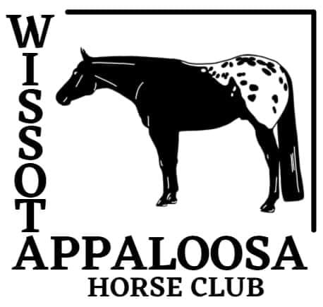

2026 Membership Application
Membership Type (Check One): Single ($10) Family ($15) Youth ($5)

Name: Spouse:
ApHC #: ApHC #:
DOB: DOB:

Address:

City:
State:
Zip Code:

Phone Number:
Email Address:
Children, 18 years old and younger, as of January 1, 2024, are included with a family membership.

Youth Name: | ApHC #: | DOB:
Youth Name: | ApHC #: | DOB:
Youth Name: | ApHC #: | DOB:
Youth Name: | ApHC #: | DOB:

Membership runs from January 1, 2026 to December 31, 2026

WSCA Membership is included if form and dues are received by May 15, 2026

Please make checks payable to: Wissota Appaloosa Horse Club.
Return form and payment of dues to:
Alison Phillips
2801 Webster Ave. S
St. Louis Park, MN 55416
Paypal or Venmo:wissotaaphc@gmail.com
Add $1 for Paypal fees

